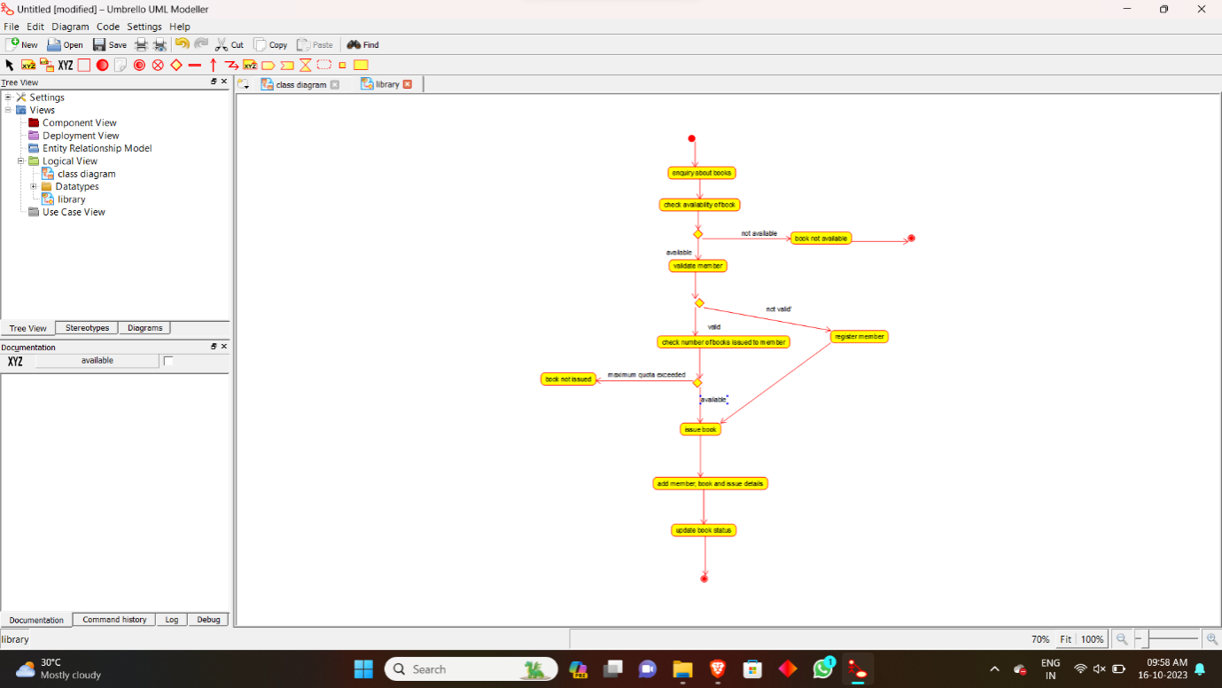

**ACTIVITY DIAGRAM FOR BOOK BANK SYSTEM**

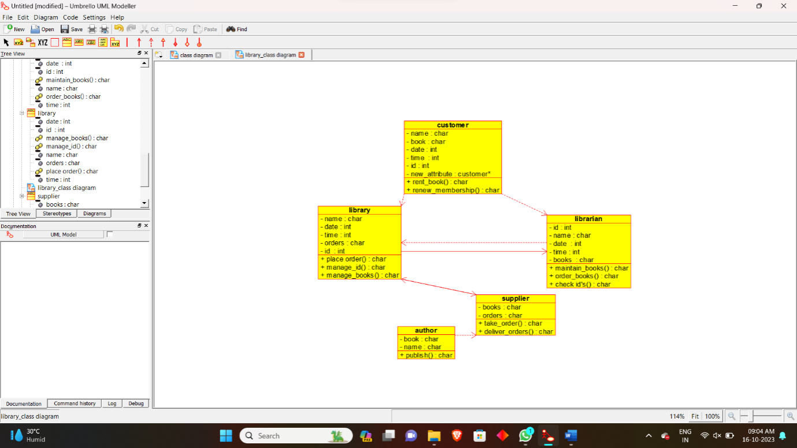

**CLASS DIAGRAM FOR BOOK BANK SYSTEM**

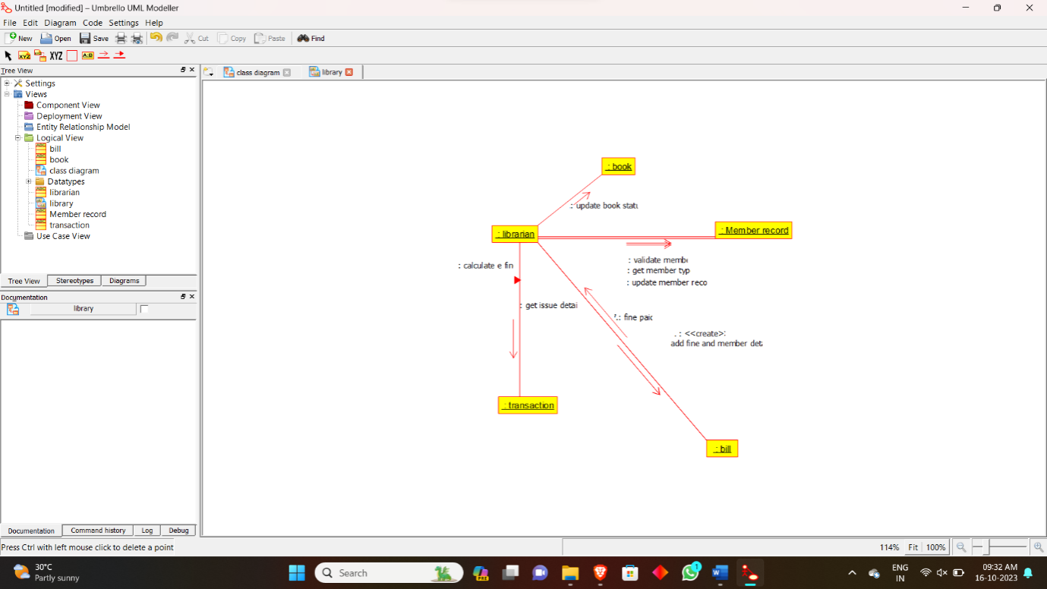

**COLLABRATION DIAGRAM FOR BOOK BANK SYSTEM**

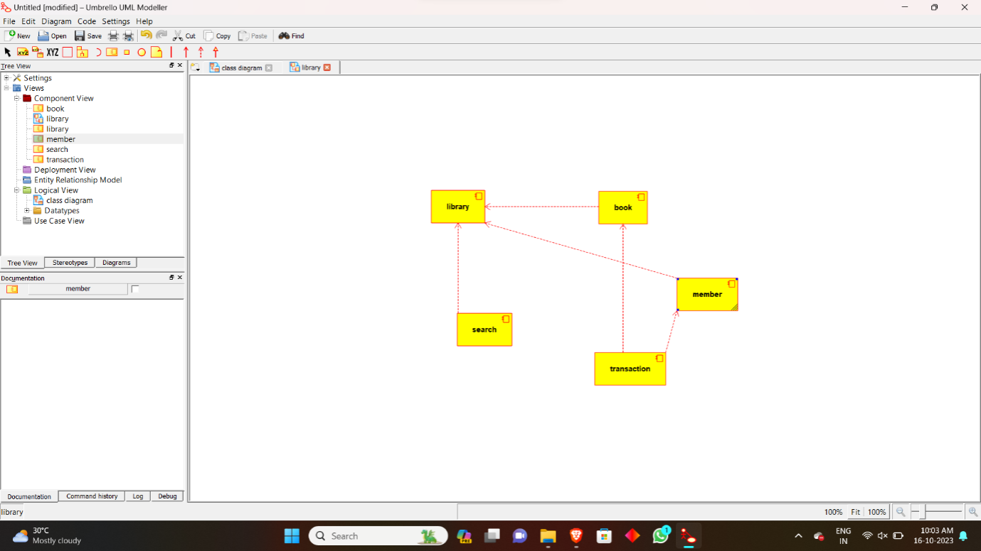

**COMPONENT DIAGRAM FOR BOOK BANK SYSTEM**

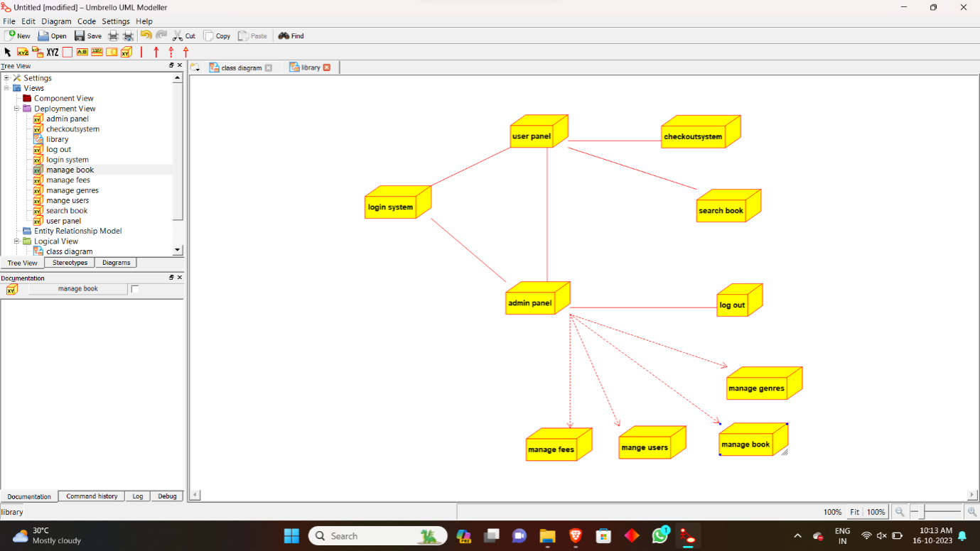

**DEPLOYMENT DIAGRAM FOR BOOK BANK SYSTEM**

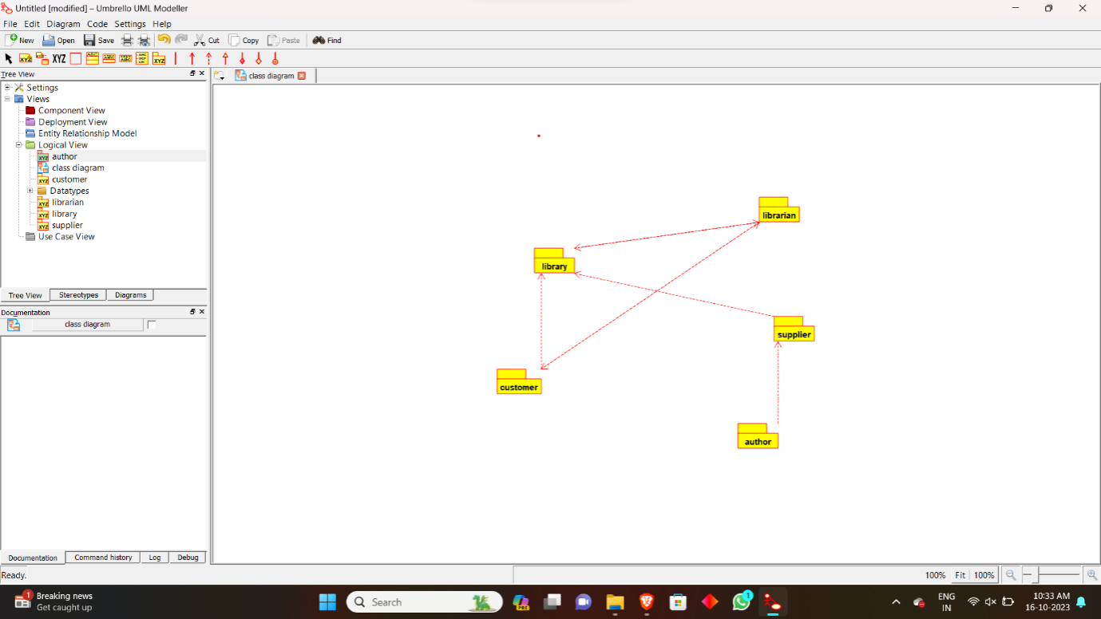

**PACKAGE DIAGRAM FOR BOOK BANK SYSTEM**

